**Migration Lab Setup**

* Since we don’t have on-premises we will be simulating the on-premise
* To Simulate On-premise
* Database:
  + We will create a VM in any cloud (AWS/Azure)
  + Install Database Management System
  + Import some sample data into database
  + Now we will setup the migration to AWS using Database Migration Service where our target will be AWS Relational Database Services (RDS)
  + Scenarios:
  + mysql to AWS RDS
  + postgreSQL to AWS RDS
  + Source:
  + Any VM in AWS/Azure
  + Destination
  + AWS RDS
* Server Migrations:
  + We will be create a VM in Azure with Windows Server 2016 and Hyper-V as hypervisor
  + Using Hyper-V we will create two virtual machines
  + Our target is to migrate these two virtual machines into AWS
  + Source:
  + Particular VM in Azure
  + Destination:
  + EC2 instance in AWS

**Database Migration using AWS Database Migration Service**

**Source Environment Creation**

* In this step we will try to create an EC2 instance where we will install the mysql database and import some data into it.
* mysql by default runs on 3306 port
* Create an Ubuntu 20.04 EC2 instance (Simulated On-premise Database Instance)  
  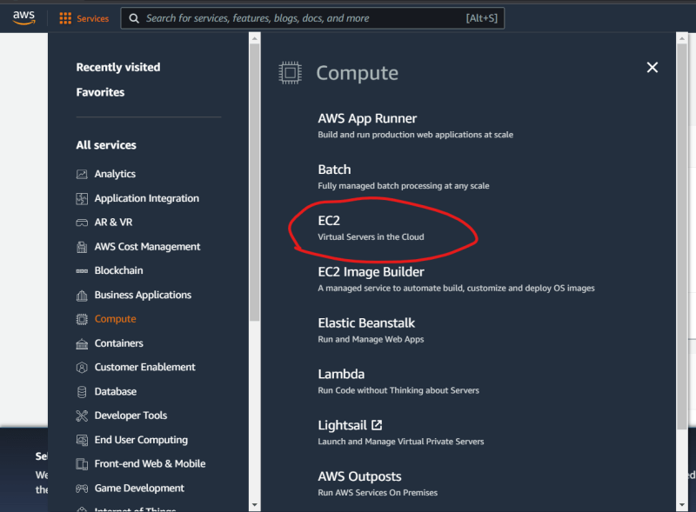  
  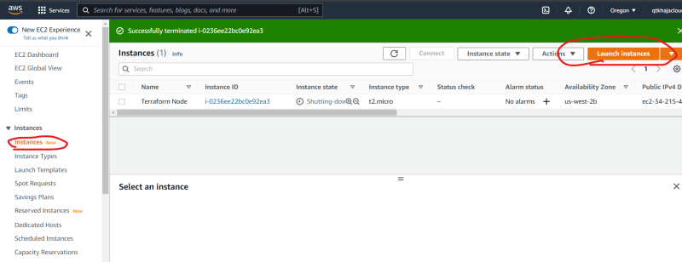  
  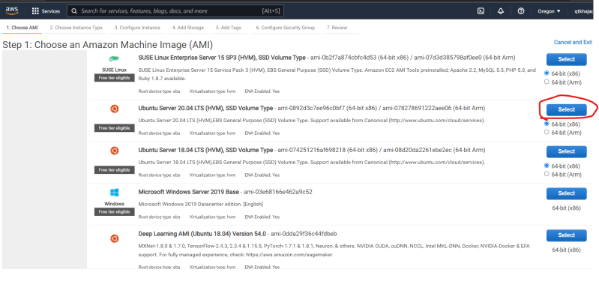  
  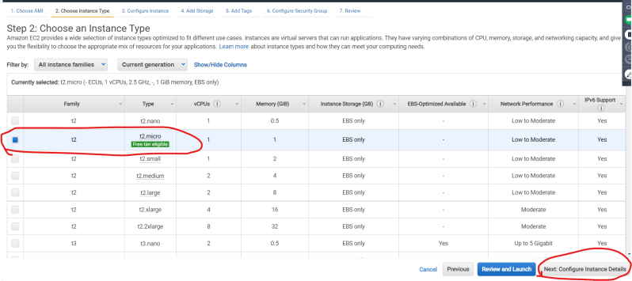  
  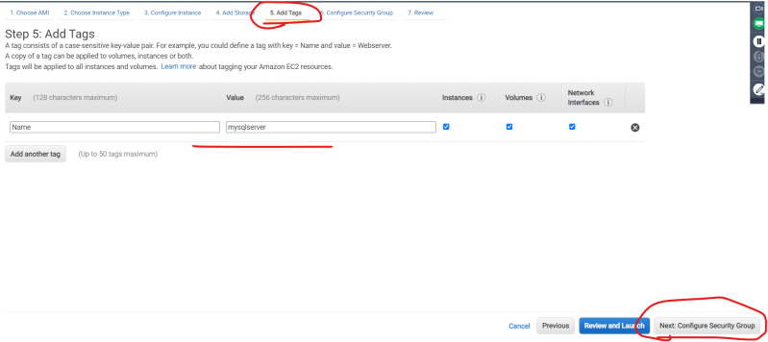  
  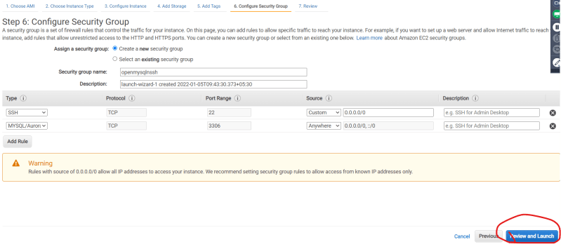  
  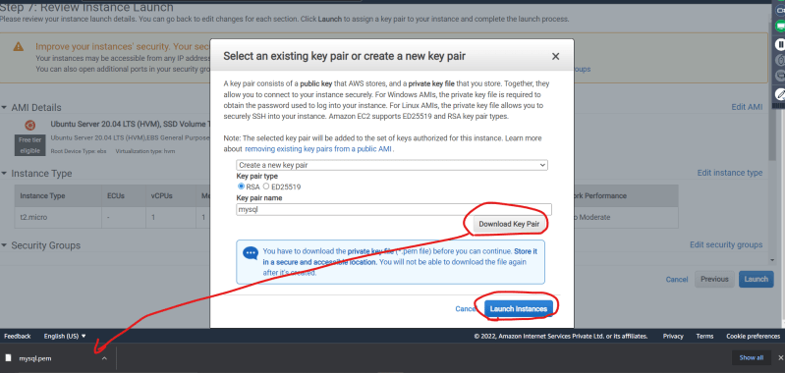  
  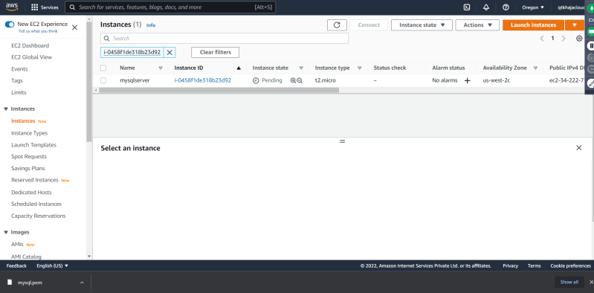  
  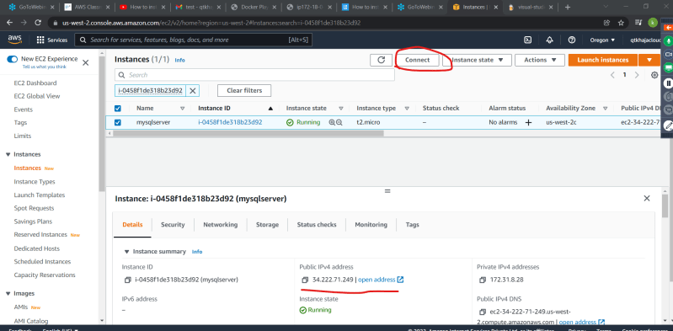
* To connect to the ec2 instance ssh -i <path to pemfile> username@ipaddress
* <https://www.digitalocean.com/community/tutorials/how-to-install-mysql-on-ubuntu-20-04> for the steps to install mysql on ubuntu 20.04
* After installing the mysql login into mysql shell  
  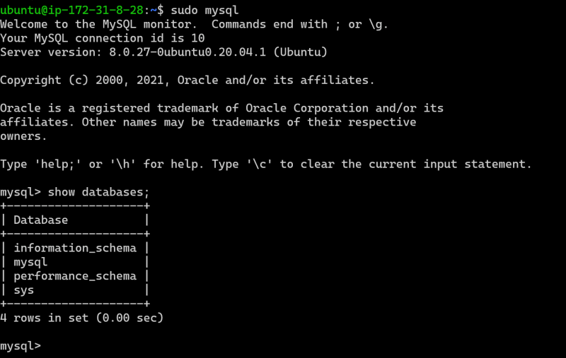
* Lets create a user for migration => awsmigration
* Now Execute the following commands

create user 'awsmigration'@'localhost' Identified by 'MotherIndia@123';

GRANT ALL PRIVILEGES ON *.* TO 'awsmigration'@'localhost';

exit

* Now login with awsmigration user

mysql -u awsmigration

